|  |  |  |
| --- | --- | --- |
| **Problem Chosen** B | **2021  MCM/ICM Summer Sheet** | **Team Control Number** mzg07 |

**How to Order and Ship Steel**

|  |
| --- |
| As a clean and efficient energy source, natural gas pipeline laying has become a key project in the field of infrastructure construction, which is not only related to the stability of energy supply, but also has far-reaching significance for promoting economic development. Based on such a social background, this question conducts in-depth research on the laying of the natural gas pipeline, involving complex challenges in many aspects such as economic cost, resource allocation and geographical factors.  In *Problem Ⅰ*, a comprehensive and in-depth analysis of many factors such as the unit steel pipe sales price, production capacity, railway and highway freight of each steel plant was conducted. By cleverly using **the twice** **Floyd-Warshall Algorithm**, the transportation route from the steel plant to the pipeline node was accurately planned, and the problem of railway and highway transportation route planning was successfully solved. On this basis, combined with **Integer Quadratic Programming(IQP)**,we established a complete model to minimize the total cost and determine the optimal ordering and transportation plan. The model was solved with the help of Lingo software, and the minimum total cost was **12.81097 billion yuan**. At the same time, the detailed ordering and transportation plans such as the supply volume of each steel plant were clarified, providing a specific decision-making basis for actual production.  In *Problem Ⅱ*, a comprehensive **sensitivity analysis** was conducted to gain a deeper understanding of the impact of each parameter in the model on the results. The specific operation is to **fluctuate the sales price and production upper limit** of each steel plant respectively, and recalculate the new total cost and ordering and transportation plan based on model I after each fluctuation. By systematically comparing the results under different parameter changes, it is concluded that the change in the sales price of $S_{6}$ steel pipes has the greatest impact on the total cost, and the change in the upper limit of $S_{1}$ steel pipe production has the greatest impact on the purchase and transportation plan and total cost, and the corresponding visualization results are given, which provides a key reference for price adjustment and capacity planning in actual production.  In *Problem Ⅲ*, the original model needs to be improved because the pipeline to be laid becomes **a tree diagram** and the network structure becomes more complex. During the improvement process, we adjusted the Floyd algorithm to adapt to the new network changes, replanned the calculation method of pipeline laying freight, and added relevant constraints to ensure the rationality and accuracy of the model. Further solutions are obtained to the minimum total cost of **14.06854 billion yuan**, as well as the new ordering plans of various steel mills, which provides a scientific and effective solution for the ordering and transportation of steel pipes for tree-shaped pipeline laying. |

**Keywords:** Floyd-Warshall Algorithm; Integer Quadratic Programming; sensitivity analysis

Contents

1 Introduction 3

1.1 Problem Background 3

1.2 Restatement of the Problem 4

1.3 Our Work 4

2 Assumptions and Justifications 6

3 Notations 7

4 Model I : Ordering and Shipping Plans for Chain Pipes 7

4.1 Data Description 7

4.2 Use the Twice Floyd's Algorithm to Find the Routes 8

4.3 Integer Quadratic Programming​​[2] 9

4.4 The Result of Model I 11

5 Model Ⅱ : Finding the Factors that Significantly Affects the Cost 13

5.1 Model Selection:Sensitivity Analysis 13

5.2 Model Building:Analysis Steps 13

5.3 The Result of Model Ⅱ 14

6 Model Ⅲ : Ordering and Shipping Plans for Tree -like Pipes 14

6.1 Comparison with Model Ⅰ 14

6.2 Building a more general model 15

6.3 The Result of Model Ⅲ 16

7 Model Evaluation and Further Discussion 17

7.1 Strengths 17

7.2 Weakness​ 18

7.3 Further Discussion 18

8 Conclusion 18

References 20

Appendices​ 21

# Introduction

## Problem Background

In today's society, the construction of energy transmission infrastructure is of vital importance to ensuring energy supply and promoting economic development.As a clean and efficient energy source, the laying of natural gas transmission pipelines has become a key project in the energy field.

This competition topic is based on the background of laying a natural gas pipeline from $A_{1}$ to $A_{15}$, and involves practical considerations in many aspects.

At the economic level, pipeline construction needs to weigh the ordering cost of steel pipes against the transportation costs to minimize the total cost. The sales prices of steel pipes from different steel mills vary. For example, $S_{1}$ the unit price of steel pipes from steel mills is 1.6 million yuan, $S_{2}$ 1.55 million yuan, etc., which directly affects the procurement cost.At the same time, there are two modes of transportation: rail and road. Railway freight rates vary according to mileage, and the road transportation cost is 0.1 million yuan per kilometer, and the choice of transportation route will further affect the total cost. The greater the mileage range of the steel $A_{j}\left(j=1,…,15\right)$ supply pipeline construction, the more steel is required at that point, which affects the transportation volume of two adjacent points on the pipeline, and ultimately affects the total cost. These factors are intertwined, constituting a complex economic planning problem.

From the perspective of resource allocation, the production capacity of each steel mill is limited, such as $S_{1}、S_{2}$ can only produce 800 units of steel, while $S_{3}$ can produce 1,000 units and so on. In addition, the steel mills that participate in the manufacturing task need to produce at least 500 units of steel. How to reasonably allocate the production tasks of each steel mill to ensure that the production capacity of the steel mill is fully utilized while meeting the needs of pipeline construction and avoiding resource waste or shortage is a resource optimization allocation problem that needs to be solved urgently.

Moreover, in pipeline construction, geographical factors such as the distribution of railways, roads, pipelines and the mileage of each section have an impact on the transportation and supply of steel pipes. This not only involves the planning of transportation routes, but also requires consideration of how to efficiently deploy resources in complex geographical networks to ensure the progress of projects be carried through smoothly.

In summary, this competition simulates the steel pipe ordering and transportation problems in the construction of natural gas pipelines, combines multiple challenges such as economic cost, resource allocation and geographical factors, and requires us to establish a reasonable mathematical model and formulate the optimal ordering and transportation plans, which can provide scientific and effective planning support for the actual energy infrastructure construction.

## Restatement of the Problem

Considering the background information and restricted conditions identified in the problem statement, we need to solve the following problems:

* **Problem 1**: Based on the main pipeline and related transportation network given in Figure 1, as well as the unit steel sales price and production capacity limit of each steel plant, unit steel railway freight rate and highway freight rate and other related information given in the question, with the ultimate goal of minimizing the total cost, first formulate an ordering plan, that is, how much steel needs to be purchased from each steel plant for pipeline laying; then formulate a transportation plan for the main pipeline steel pipes, that is, how much steel each steel plant needs to transport to each pipeline node, and how much steel each pipeline node needs to transport to the left and right routes respectively.
* **Problem 2**: Conduct a sensitivity analysis on the model obtained in *Problem Ⅰ* to determine which steel mill’s steel pipe sales price change has the greatest impact on the purchase and transportation plan and total cost, and give specific data results; determine which steel mill’s steel pipe production upper limit change has the greatest impact on the purchase and transportation plan and total cost, and give specific data results.
* **Problem 3**: Based on the main pipeline and related transportation network given in *Figure 2*, give the model and results as required by *Problem Ⅰ*.

## Our Work

In the process of solving this competition, our team carried out a series of intensive and orderly work. The following is a detailed description of our work content:

**1.Analysis of Problem Ⅰ**

For *Problem Ⅰ*, we deeply analyzed its core points and clarified the need to formulate ordering and transportation plans with the goal of minimizing total costs. This involves comprehensively considering multiple factors such as the unit steel sales price, production capacity limit, railway and highway freight rates of each steel plant, and building a suitable mathematical model to solve the optimal solution.

**2.Modeling difficulties and solutions**

* **Difficulty 1**: Different billing methods for railways and highways. Since railway freight rates do not change continuously with mileage and the lines are multi-branched, we set breakpoints at the junction of railways and highways and perform Floyd's algorithm twice. First, find the most economical route from the steel plant to the junction, and then obtain the most economical route and freight rate for the steel plant to reach the main pipeline node through reasonable abstraction and discarding the sub-economic route.
* **Difficulty 2**: Steel allocation problem. In order to ensure that steel is only transported to adjacent sections, we include information about construction roads in the weighted graph to make the transportation plan more reasonable and feasible.
* **Difficulty 3**: Freight during distribution. When considering the freight of distributing steel along the pipeline, we approximate it as a continuous problem to simplify the calculation process.

**3. Establishment of the integer quadratic programming model**

To build this model, we went through the following three steps.

* **Step 1**:Determine the decision variables. Set up decision variables to represent the amount of steel transported by the steel plant to the main pipeline node and the amount of steel distributed by the pipeline node to each branch, and the decision variables consider the situation where some steel plants do not provide steel.
* **Step 2**:Establish the objective function. The total cost includes the production cost and transportation cost of the steel pipe. The transportation cost is divided into the freight of the steel plant to the pipeline node and the freight generated when distributing steel along the pipeline, and the production cost is related to the sales price and transportation volume of the steel plant. By combining these factors, the objective function is established.
* **Step 3**:Set constraints. According to the actual situation, a series of constraints are set. Such as the demand constraints on the amount of steel to be laid in each pipeline, the boundary condition constraints, and the constraints on the steel plant's production capacity and the manufacturing tasks involved, etc., to ensure the rationality and feasibility of the model.

**4. Model solution and result analysis**

We chose Lingo software to solve the integer quadratic programming model and obtained the minimum total cost and the ordering and transportation plan of steel. For *problem Ⅱ* we conducted a sensitivity analysis on the model to study the impact of changes in steel mill sales prices and production caps on purchase and transportation plans and total costs. By fluctuating the relevant parameters of each steel mill, recalculating the total cost and ordering and transportation plan, we obtained the key steel mills with the greatest impact on costs, which provided an important reference for actual production ordering planning.

**5. Model expansion**

When solving *problem Ⅲ*, we expanded the model to make it applicable to the case of tree-shaped pipelines. By comparing with *model Ⅰ*, we analyzed the similarities and differences between the two and established a more general model. Similarly, the two Floyd algorithms and integer quadratic programming were used to obtain the corresponding ordering and transportation plans.

**6. Model evaluation and improvement**

During the research process, we summarized and evaluated the advantages and disadvantages of the model. The advantages of the model include the ability to accurately calculate the minimum freight, effectively characterize multiple factors, and have robustness and scalability; the disadvantage is that there are certain errors in characterizing freight. In response to the shortcomings, we proposed corresponding improvement directions. At the same time, we proposed the direction of future expansion of the model, such as incorporating the upper limit of transportation capacity into the model consideration range.

Through the above series of work, we have gradually overcome various problems in the competition and provided scientific and effective decision-making support for the ordering and transportation of steel pipes in the construction of natural gas pipelines.

# Assumptions and Justifications

To simplify our problem,we make the following basic assumptions,each of which is properly justified.

1. **We assume that the amount of steel required is equal to the total length of the main pipeline, ignoring steel losses during transportation and construction.**

In the actual long-distance transportation process, there will be cases of steel damage and loss; in the actual cutting and assembly process, processing allowances need to be reserved, and scraps are inevitable: in short, it is impossible to utilize 100% of the steel. We make an idealized assumption statement here to highlight the main contradiction of the problem and to facilitate subsequent application to real-life situations.

1. **We assume that the steel is treated as a point mass during transportation.**

Because the transportation distance is generally much longer than the unit length of the steel, and for the convenience of calculation, only the distance from the starting point to the end point is considered, and the length of the steel itself is not considered. And after the steel is assumed to be a mass point, $A_{j}$ the unit space of the node can accommodate enough steel, and They are strictly placed on this node without any offset, which facilitates further analysis of the problem.

1. **We assume that vehicles distribute steel along the main pipeline by transporting 1 kilometer and unloading 1 unit of steel, and do not consider the number of transport vehicles and the additional fuel subsidies incurred by stops.**

According to the highway transportation charging rules given in the question, this method of allocating steel is the most economical way of highway transportation without considering the actual conditions such as fuel costs and manpower. Therefore, according to the meaning of the question, the question itself does not take into account the relevant actual conditions, and we make a supplementary statement here.

1. **We assume that railway freight rates are calculated based on the mileage of the entire journey settled in one go, rather than at each stop.**

According to Articles 12 and 13 of the *Railway Freight Rates Rules* issued on February 28, 1990, since goods are not unloaded during railway transportation, the full vehicle freight is calculated based on the freight mileage from the departure station to the final destination, assuming that it complies with regulations.

# Notations

The key mathematical notations used in this paper are listed in Table 1 .

Table 1: Notations used in this paper

|  |  |
| --- | --- |
| **Symbol** | **Description** |
| $$S_{i}$$ | Steel Mills $i$ |
| $$s_{i}$$ | $S_{i}$ Production capacity |
| $$A_{j}$$ | Natural gas pipeline node |
| $${len}_{j}$$ | The length of the pipe between $A_{j}$ and $A_{j+1}$ |
| $$x_{ij}$$ | The amount of steel transported from $S_{i}$ to $A_{j}$ |
| $$p_{i}$$ | The selling price per unit of steel from $S_{i}$ |
| $$c_{ij}$$ | The freight of shipping steel from $S_{i}$ to $A_{j}$ |
| $${flag}_{i}$$ | 0-1 decision variable |

# Model I : Ordering and Shipping Plans for Chain Pipes

## Data Description

1. Steel mill information

There are 7 steel mills $S_{1}\sim S_{7}$, with production capacities (unit: units) of 800, 800, 1000, 2000, 2000, 2000, 3000, and steel pipe sales prices (unit: 10,000 yuan/unit) of 160, 155, 155, 160, 155, 150, 160. Production capacity limits the order quantity, and sales price affects the procurement cost, and both act together on the ordering decision.

2. Shipping Information

(1) Railway freight rates: The price is tiered by mileage. The price is RMB 200,000 per unit for mileage ≤ 300 km. The price increases for every 50 km increase ( up to 1,000 km). The price increases by RMB 50,000 for every 100 km increase above 1,000 km. The relationship between mileage and freight rates determines the cost of railway transportation and affects the choice of transportation routes.

(2) Highway freight rate: fixed at RMB 10,000 per kilometer for one unit of steel pipe. The per-kilometer charging method affects the calculation of highway transportation costs. It is worth noting that the question requires that less than a whole kilometer be counted as a whole kilometer.

(3) Transportation network: including pipelines (double thin lines), railways (thick lines), roads (single thin lines) and their mileage. The complex network provides a variety of transportation routes, and the optimal route must be determined by comprehensively considering costs and geographical conditions to ensure the supply of steel pipes.

## Use the Twice Floyd's Algorithm to Find the Routes

Freight plays an important role in the total cost. The length and type of each road section are different, and the freight required to pass through this section will be different. Based on the data information given in the question, it is not difficult to abstract the network into a weighted graph. The nodes in the graph represent the sites, and the edges of varying thickness represent the different freight rates required, as shown in the figure.

Therefore, we transform this problem into the All Pairs Shortest Paths (APSP) problem, that is, to find the most economical route between the required node pairs in the graph. This problem is usually solved using the Floyd-Warshall Algorithm[1].

After analyzing the background of the problem, we know that most of the steel is transported by rail first and then by road. Only $S_{1}、S_{6}、S_{7}$ can reach the pipeline node by road . Multiple bifurcations. Based on *assumption 4*, we might as well set breakpoints at the junction of the railway and the highway $B_{k}(k=1,…,17)$, and first use the Floyd-Warshall Algorithm to find $S_{i}$ the $B_{k}$ most economical route, as shown in **Figure 1(b)**.

After obtaining $S_{i}$ the $B_{k}$ most economical route, we can abstract the route passing through the intermediate point $M_{1}、M_{2}、M_{3}$ into a $S_{i }$ direct $B_{k}$ route to. We can further discard $S_{i}$ the $B_{k}$ sub-economic routes because they will not participate in the formation of the most economical route. Therefore, we get the edge weight graph shown in **Figure 1(c)**.

It is worth noting that the route representing the road section along the main pipeline should not be forgotten to be added, because it is very likely that $A_{j}$ the most economical route to a certain destination is through the road on the main pipeline. Only by adding the route $A_{j}$ between $A_{j+1}$ and can it be ensured that there will be no cross-node allocation during the steel allocation stage, that is, $A_{j}$ the steel transported to will only supply ${len}_{j}$ the pipeline sections of $j<15$ and here ${len}_{j+1}$.

Finally, we perform the Floyd-Warshall Algorithm again on the graph we just obtained to obtain the most economical route $S_{i}$ to the destination $A_{j}$, as shown in **Figure 1(d)**, and its specific freight cost $c_{ij}$.

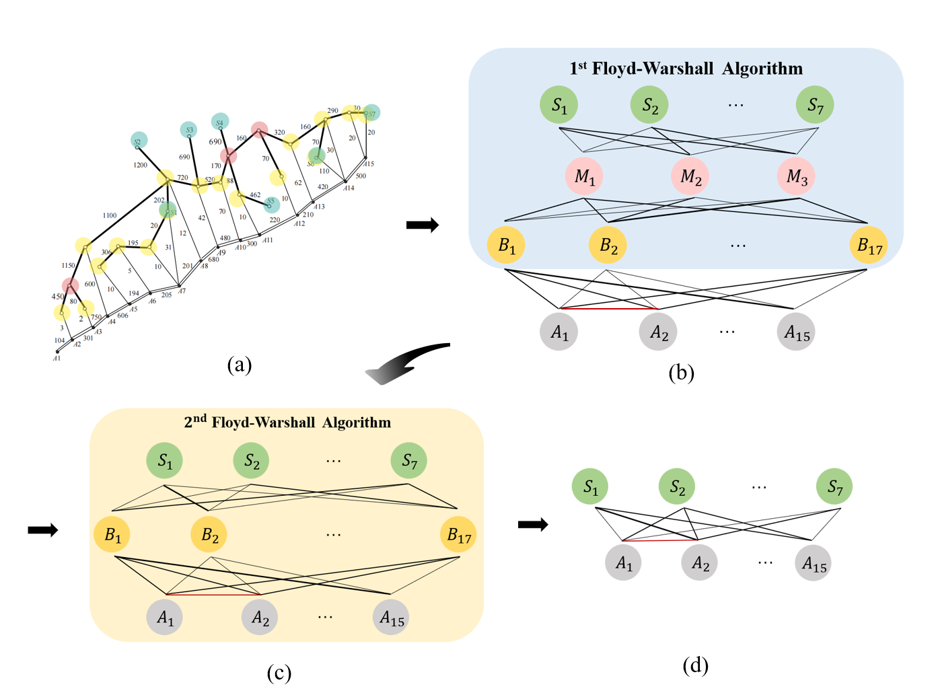

**Figure 1:the twice floyed-warshall algorithm**

## Integer Quadratic Programming​​[2]

* **Determine the decision variables**: According to the analysis of *Problem Ⅰ in 1.2 Restatement of the Problem*, we need to set up decision variables $x_{ij}$ to represent the amount of steeltransported from $S_{i}$ to $A_{j}$, then $\sum_{i=1}^{15}{x_{ij}}$ is the ordering plan, and $\sum_{j=1}^{7}{x_{ij} }$ is the transportation allocation plan.

In addition, considering the possibility that some steel mills do not provide steel, we set the decision variable ${flag}_{i}$, ${flag}_{i}$ =0 or 1.

* **Establish the objective function**: The total cost includes the production cost and transportation cost of the steel pipe. The transportation cost is divided into two parts in this paper. The first part is the freight from $S_{i}$ to the pipeline node $A_{j}$, which is expressed as:

|  |  |
| --- | --- |
| $$\sum_{i=1}^{7}{\sum_{j=1}^{15}{x_{ij}∙c_{ij}}},$$ | () |

The second component is the freight cost incurred in distributing the steel along the pipeline, expressed as:

|  |  |
| --- | --- |
| $$\sum_{j=1}^{14}{(\frac{{R_{j}}^{2}}{2}}+\frac{{L_{j+1}}^{2}}{2})×0.1,$$ | () |

Among them, the steel $R_{j}$ is transported to the point for laying the pipeline between $A_{j}$ and $A_{j+1}$, and the steel $L_{j}$ is transported to the node for laying between $A_{j}$ and $A_{j-1}(j>1)$. We will use a graphical method to calculate the cost of allocating steel along the jth pipeline. As shown in **Figure 2**, the cost can be approximated as the area enclosed by the coordinate axis and the oblique line.

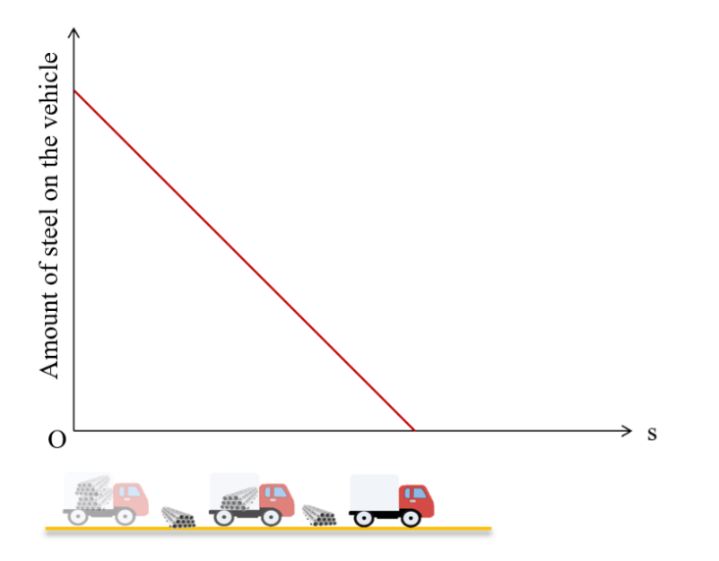

**Figure 2: the algorithm for allocation**

The production cost of steel is

|  |  |
| --- | --- |
| $\sum_{i=1}^{7}{(\sum_{j=1}^{15}{x_{ij})}∙p_{i}}$. | () |

In summary, the objective function

|  |  |
| --- | --- |
| $Z=\sum_{i=1}^{7}{\sum_{j=1}^{15}{x_{ij}∙c_{ij}}}+\sum_{j=1}^{14}{(\frac{{R_{j}}^{2}}{2}}+\frac{{L_{j+1}}^{2}}{2})×0.1+\sum_{i=1}^{7}{(\sum_{j=1}^{15}{x_{ij})}∙p_{i}}$*,* | () |

finding the minimum value of Z yields the optimal ordering and shipping plan.

* **Constraints**:

|  |  |
| --- | --- |
| $\sum_{i=1}^{7}{x_{ij}}=R_{j}+L_{j}$, | () |
| $L_{1}=0$, | () |
| $R_{15}=0$, | () |
| ${len}_{j}=R_{j}+L_{j+1}$, | () |
| $500×{flag}_{i}≤\sum_{j=1}^{15}{x_{ij}}≤s_{i}×{flag}_{i}$. | () |

## The Result of Model I

We choose Lingo software to solve the IQP model, and finally conclude that the minimum total cost required $Z_{min}$ is 12.81097 billion yuan. At the same time, the ordering and transportation plan of steel is given, as shown in the following table:

Table 2 : Steel Ordering Program

|  |  |
| --- | --- |
| **Steelworks** | **Steel Supply** |
| $$S_{1}$$ | 800 |
| $$S_{2}$$ | $$800$$ |
| $$S_{3}$$ | 1000 |
| $$S_{4}$$ | $$0$$ |
| $$S_{5}$$ | $$1329$$ |
| $$S_{6}$$ | $$1242$$ |
| $$S_{7}$$ | 0 |

It can be seen that steel plants $S_{4}$ and $S_{7}$ do not provide steel, and $S_{5}$ provides the most steel. The steel supply of each steel plant meets the requirements of the question, which verifies the correctness of the model.

$S_{i}$ amount of steel $x_{ij}$ shipped by the steel mill $A_{j}$ is shown in **Figure 3**.

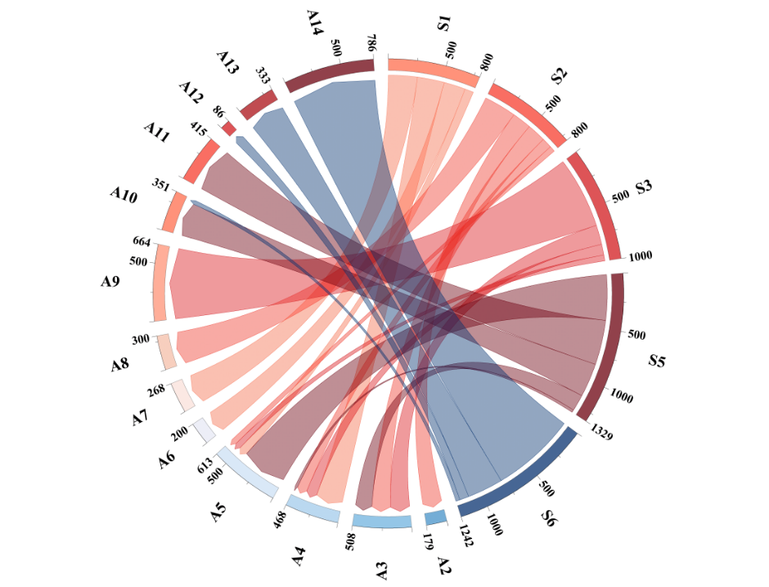

**Figure 3:order & transportation plan of Model Ⅰ**

By observing the chord diagram, we can conclude that the steel at point $A_{9}$ is all provided by $S_{3}$; steel plant $S_{6}$ provides steel to $A_{10},A_{12},A_{13}$ and $A_{14}$, with the most steel shipped to point $A_{14}$, and other similar information.

The specific transportation path of steel is shown in **Figure 4(b)** below, and the nodes in the figure correspond to those in**Figure 4 (a)**. Through **Table 2**, combined with **Figure 4(b)**, we can know through local analysis why $S_{4}$ and $S_{7}$ have no steel orders: the freight from $S_{5}$ to key node 29 is lower than that of $S_{4}$, and the sales price of $S_{5}$ is also lower, so all the orders of $S_{4}$ are taken away by $S_{5}$. Similarly, the freight from $S_{7}$ to node 36 is greater than the freight from $S_{6}$ to 36, the freight from $S_{7}$ to 15 is greater than the freight from $S_{6}$ to 14, and the sales price of $S_{7}$ is greater than $S_{6}$, so $S_{7}$ has no orders.

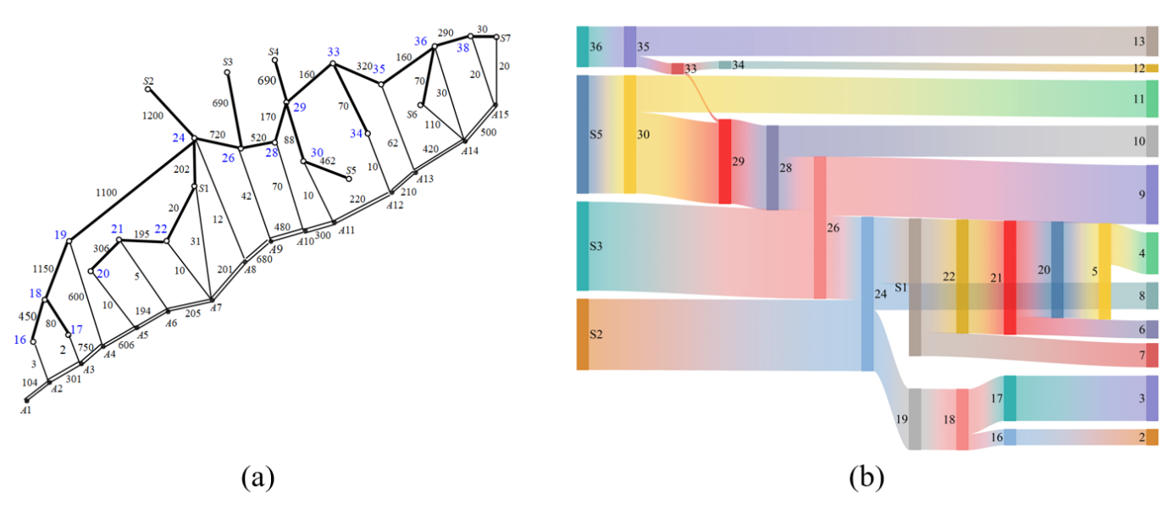

**Figure 4:specific transportation plan**

# Model Ⅱ : Finding the Factors that Significantly Affects the Cost

## Model Selection:Sensitivity Analysis

In *Problem 1*, we built the model *Ordering and Shipping Plans for Chain Pipes*. The model contains multiple input parameters such as the steel mill's sales price, production limit, and transportation costs, and has multiple output results such as total costs, ordering and transportation plans. Moreover, there is a clear mathematical or logical relationship between the parameters and the outputs in the model, and the output results can be recalculated by changing the parameter values.

Sensitivity analysis is a method to study and analyze the sensitivity of a system (or model) state or output changes to changes in system parameters or surrounding conditions. It is used to evaluate the responsiveness of the model output to changes in input parameters. For example, in the steel pipe ordering and transportation problem, sensitivity analysis can understand how small changes in parameters such as the steel mill's sales price and production limit affect the total cost and ordering and transportation plans.

Therefore, we decided to perform sensitivity analysis on the corresponding parameters to solve *Problem Ⅱ*.

## Model Building:Analysis Steps

* **Determine the analysis object**: According to the analysis of *Problem 2* in *1.2 Restatement of the Problem*, we have determined that the parameters to be analyzed are the steel plant's sales price and the upper limit of production.
* **Set the initial state**: In *4.4 The Result of Model Ⅰ*, we calculated the minimum total cost and the optimal ordering and transportation plan. We set them as the initial state $Q_{0}$.
* **Parameter change**: Because the initial values ​​of the analysis object are different, we need to calculate the impact of parameter changes on the initial state and compare the influence of different parameters. Therefore, we need to set the parameter change rate $η=\left|\frac{Q_{0}-Q}{Q_{0}}\right|×100\%$ as the independent variable.

(1) For the ex-factory sales price of steel pipes, the sales price $p_{i}$ of steel plant $S_{i}$ is continuously fluctuated up and down by 5%, and the prices of other steel plants are kept unchanged.

(2) For the upper limit of steel pipe production, the upper limit of the production $s_{i}$ of steel plant $S_{i}$ is continuously fluctuated up and down by 5%, and the upper limit of the production of other steel plants is kept unchanged.

* **Recalculation**: In response to the situation after parameter changes, change the relevant parameters based on *Model I* to obtain the new total cost **Z** and the new ordering and transportation plan.

## The Result of Model Ⅱ

As shown in **Figure 5 (a)**, after the sales price $p_{i}$ fluctuated up and down by 5%, $S_{7}$ basically did not change, $S_{6}$ showed a positive growth trend from -5% to 5%, and the change in total cost was the largest. It can be concluded that the change in the sales price of the steel pipe of S_6 has the greatest impact on the total cost.

As shown in **Figure 5(b)**, after the upper limit of production $s_{i}$ fluctuated up and down by 5%, $S_{7}$ basically did not change, $S_{1}$ showed a negative growth trend from -5% to 5%, and the change in total cost was the largest. It can be concluded that the change in the sales price of the steel pipe of $S_{1}$ has the greatest impact on the total cost.

Moreover, we can also observe from the figure that the changes in $p_{i}$ and $s_{i}$ of $S_{7}$ and $S_{4}$ have almost negligible effects on the total cost; the sales price rises, the total cost increases; the upper limit of production capacity increases, and the total cost basically shows a downward trend.

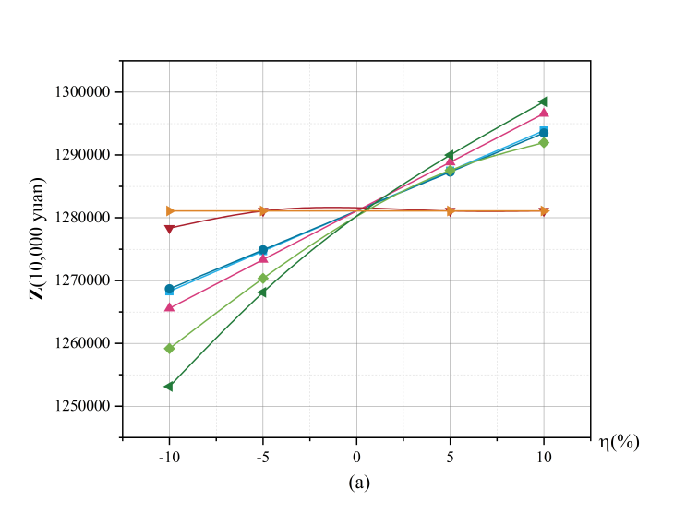 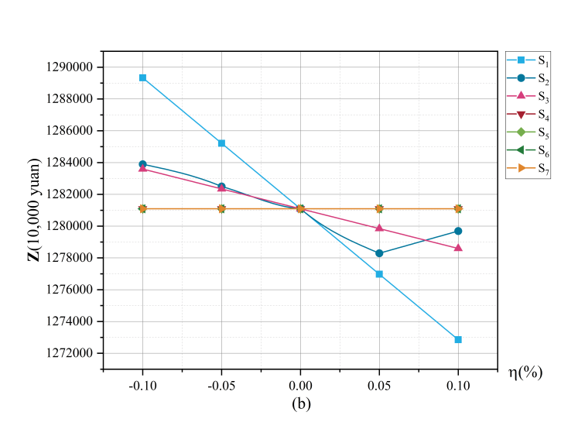

**Figure 5:sensitivity analysis**

# Model Ⅲ : Ordering and Shipping Plans for Tree-like Pipes

## Comparison with Model Ⅰ

When the pipelines to be laid are transformed into a tree diagram, the network composed of railways, roads and pipelines becomes more complicated. The specific manifestations are:

* The previously set border point $B_{k}$ or railway node coincides with the natural gas pipeline node $A_{j}$.
* Natural gas pipelines to be laid appear between railway nodes.
* Multiple natural gas pipeline nodes $A_{j}$ are connected to more pipelines to be laid.

In order to solve the above problems, we try to improve the model proposed in the first question so that it can handle more general situations.

## Building a more general model

### the Twice Floyd's Algorithm

Similar to the first question, since the railway freight rate rises in a stepwise manner, we need to first use the Floyd-Warshall Algorithm to find the most economical route from $S_{i}$ to $B_{k}$. However, due to the significant increase in the complexity of the graph, the previously set border point $B_{k}$ cannot perfectly divide the transportation network, so we will add an intermediate node similar to the border point and expand the name of $B_{k}$ to a breakpoint. When setting, not only need to consider At the junction of railways and highways, it is also necessary to consider the overlap of nodes between railways and pipelines to be laid.

In the worst case, we need to set all railway nodes as breakpoints, that is, we need to use the Floyd-Warshall Algorithm algorithm to find the most economical route from $S_{i}$ to all railway nodes.

The second Floyd-Warshall Algorithm is similar to the first question.

### Integer Quadratic Programming

In this section, the calculation of the freight cost for distributing steel along the pipeline has changed.

We express the laying freight cost as

|  |  |
| --- | --- |
| $$\frac{1}{2}∙\sum_{j=1}^{n}{\sum_{k=1}^{m}{{{Pave}_{jk}}^{2}}}×0.1,$$ | () |

Where $n$ is the number of pipeline nodes, and $m$ is the number of pipelines to be laid that are connected to the pipeline nodes. For *Figure 2 in the title*, n=21, m=3. $Pave$ can be seen as a general extension of $L$ and $R$ in *Model Ⅰ*.

At the same time, we need to further constrain the model:

For most pipelines, the constraints are as follows:

|  |  |
| --- | --- |
| $${len}_{j}=\sum_{k=1}^{m}{{Pave}_{jk}}+\sum_{k=1}^{m}{{Pave}_{(j+1)k}}.$$ | () |

However, there exist some special pipelines whose constraints are difficult to state, but similar to *Eq.(2)*, the length of the pipe is equal to the sum of the allocated steel quantities at both ends.

If the number of pipes connected to $Aj$ is 1:

|  |  |
| --- | --- |
| $${Pave}_{j2}=0,{Pave}_{j3}=0.$$ | () |

If the number of pipes connected to $Aj$ is 2:

|  |  |
| --- | --- |
| $${Pave}_{j3}=0.$$ | () |
| $$\sum_{i=1}^{7}{x_{ij}}=\sum_{k=1}^{m}{{Pave}_{jk}}.$$ | () |

Other constraints are as shown in *Model Ⅰ* and are not listed here.

We will use *Figure 2* as an example of this general model. It can be seen that the objective function is as follows:

|  |  |
| --- | --- |
| $$Z=\sum_{i=1}^{7}{(\sum_{j=1}^{21}{x_{ij}})∙p_{i}}+\sum_{i=1}^{7}{\sum_{j=1}^{21}{x_{ij}}∙c_{ij}}+\frac{1}{2}∙\sum_{j=1}^{n}{\sum_{k=1}^{m}{{{Pave}_{jk}}^{2}}}×0.1.$$ | () |

## The Result of Model Ⅲ

Like *Model Ⅰ*,we choose Lingo software to solve the IQP model, and finally conclude that the minimum total cost required $Z_{min}$ is 14.06854 billion yuan. At the same time, the ordering and ordering plan of steel is given, as shown in the following table and figure:

Table 2 : Steel Ordering Program

|  |  |
| --- | --- |
| **Steelworks** | **Steel Supply** |
| $$S_{1}$$ | 800 |
| $$S_{2}$$ | $$800$$ |
| $$S_{3}$$ | 1000 |
| $$S_{4}$$ | $$0$$ |
| $$S_{5}$$ | $$1430$$ |
| $$S_{6}$$ | $$1873$$ |
| $$S_{7}$$ | 0 |



**Figure 6:order & transportation plan of Model Ⅲ**

# Model Evaluation and Further Discussion

## Strengths

* This model cleverly uses twice the Floyd algorithm to accurately calculate the minimum freight from the steel plant to the pipeline node to be laid, successfully solves the complex problem of railway and highway transportation route planning, and provides a reliable basis for the optimization of transportation routes.
* With the help of integer quadratic programming, the model comprehensively and effectively integrates multiple factors such as economic cost, resource allocation and geographical location, formulates optimal ordering and transportation plans, and provides scientific and effective decisions for actual energy infrastructure construction support.
* In this study, we conducted an in-depth sensitivity analysis to effectively verify the robustness and robustness of the model. Through this analysis, the key steel plants that have the most significant impact on costs are accurately identified, providing key guidance for actual production order planning.
* This model exhibits excellent scalability. When the pipeline to be laid takes on a more complex shape, such as a tree diagram, a forest, or a ring structure, this model only needs to moderately increase the corresponding constraints, and it can efficiently and accurately model the actual situation, fully demonstrating Its strong adaptability and flexibility.
* When characterizing the freight cost of laying steel pipes, this model approximates it as a continuous problem to simplify the calculation process. This treatment method leads to a certain degree of error in the final solution (the error rate is less than 1%). Although the error is relatively small, it may still have a subtle impact on the decision.

## Further Discussion

Although this model simplifies the calculation process by approximating the laying transportation cost as a continuous problem, future work can explore more accurate methods to consider the discrete nature of transportation costs to better fit the actual situation of transportation logistics.

The model can further take the upper limit of transportation capacity into comprehensive consideration. Through careful observation and in-depth analysis of relevant data, it is not difficult to find that some nodes (such as nodes 24 and 26 in the Sankey diagram) are hubs of the steel transportation network. In view of the objective fact that there is an upper limit to the transportation capacity of the transportation route in actual problems, the model can strengthen the constraints of transportation planning to more perfectly adapt to the actual situation and ensure the smoothness and efficiency of the transportation process.

The current model has the potential to cope with larger and more complex transportation networks. When the graph of the pipeline to be laid is not limited to a linear structure, but presents complex forms such as tree graphs, forests, loops, and even hypergraphs, this model can be flexibly improved in combination with actual conditions. In addition, when the scale of the transportation network is further expanded and the transportation methods are more diversified, for example, when considering the national pipeline system and adding complex situations such as water transportation, the model can introduce a series of advanced optimization algorithms in a timely manner to properly handle situations with higher complexity and larger data volumes, demonstrating strong processing capabilities.

# Conclusion

The model established in this study shows many advantages in solving the problem of steel pipe ordering and transportation. The use of the two Floyd algorithms can accurately calculate the minimum freight from the steel plant to the laying site, providing a reliable guarantee for the optimization of the transportation route and successfully coping with the complex railway and road transportation network planning problem. With the help of integer quadratic programming, the model comprehensively and effectively integrates multiple factors such as economic cost, resource allocation and geographical location to formulate the optimal ordering and transportation plan, providing scientific and effective support for decision-making in actual energy infrastructure construction. In the process of research, through in-depth sensitivity analysis, the robustness of the model was fully verified, and the steel mills with the most critical impact on cost were accurately identified, providing important guidance for order planning in actual production. In addition, the model also has excellent scalability. When faced with more complex pipeline shapes, such as tree diagrams, forest diagrams or ring structures, only the corresponding constraints need to be moderately increased to efficiently and accurately simulate the actual situation, which effectively reflects the model's strong adaptability and flexibility.

However, the model is not perfect. When characterizing the cost of steel pipe freight, in order to simplify the calculation process, an approximate treatment method is used to treat it as a continuous problem, which leads to a certain degree of error in the final solution. Although the error rate is less than 1%, it may still have a subtle impact on the decision. In view of this shortcoming, future research can explore more accurate methods to fully consider the discreteness of transportation costs and make it more in line with the actual transportation logistics situation. At the same time, the model can further take the upper limit of transportation capacity into comprehensive consideration. Through careful observation and in-depth analysis of relevant data, it is not difficult to find that some nodes (such as nodes 24 and 26 in the Sankey diagram) play a pivotal role in the steel pipe transportation network. In view of the objective fact that there is an upper limit of transportation capacity for transportation routes in actual problems, strengthening the constraints of transportation planning can make the model better adapt to the actual situation and ensure the smoothness and efficiency of the transportation process. The current model has potential in dealing with larger and more complex transportation networks. When the graph of pipeline laying is not limited to a linear structure, but presents a complex form such as a tree diagram, a forest diagram, a ring diagram, or even a hypergraph, the model can be flexibly improved according to the actual situation. In addition, as the scale of the transportation network continues to expand and the modes of transportation become increasingly diversified, for example, when considering a nationwide pipeline system and adding complex situations such as water transportation, the model can promptly introduce a series of advanced optimization algorithms to properly handle situations with higher complexity and larger data volumes, demonstrating strong processing capabilities.

# References

*[1]Sixi S ,Huiming Z .MODIFIED ALGORITHMS OF FLOYD[J].Asia-Pacific Conference on Communications,1995.*

*[2]P. H. Lee,and C. M. Kyung."CHANNEL ROUTING USING 0-1 QUADRATIC INTEGER PROGRAMMING."JTC-CSCC : Joint Technical Conference on Circuits Systems, Computers and Communications (1992):*

# Appendices

|  |
| --- |
| Appendix 1 |
| Introduce: Floyed Algorithm求解最小运费 |
| void floyd()  {  for(int k = 1; k <= n; k++)  for(int i = 1; i <= n; i++)  for(int j = 1; j <= n; j++){  d[i][j] = min(d[i][j], d[i][k] + d[k][j]);  c[i][j] = min(c[i][j],cost(d[i][k] + d[k][j]));  }  }  int main()  {  cin >> n >> m;  for(int i = 1; i <= n; i++)  for(int j = 1; j <= n; j++){  if(i == j){  d[i][j] = 0;  c[i][j] = 0;  }  else {  d[i][j] = inf;  c[i][j] = inf;  }  }  while(m--)  {  int x, y, z;  cin >> x >> y >> z;  d[x][y] = min(z, d[x][y]);  d[y][x] = min(z, d[y][x]);  }  floyd();  int cnt = 0;  int s[7] = {23, 25, 27, 32, 31, 37, 39};  int rail[17] = {16, 17, 19, 20, 21, 22, 23, 24, 26, 28, 30, 34, 35, 37, 36, 38, 39};    for(int i = 0; i < 7; i++){  for(int j = 0; j < 17; j++){  cout << s[i] << ' ' << rail[j] << ' ' << c[s[i]][rail[j]] <<endl;  }  }  } |

|  |
| --- |
| Appendix 2 |
| Introduce: Lingo 求解IQP 模型代码（省略数据） |
| model:  SETS:  row /1..7/: flagi, si, Price_i;  col /1..15/: Rj, Lj;  f /1..14/: len;  arr(row, col): Xij, c;  ENDSETS  DATA:  c =  Price_i =  len = 104, 301, 750, 606, 194, 205, 201, 680, 480, 300, 220, 210, 420, 500;  si =  ENDDATA  ! 目标函数;  MIN = @SUM(arr(i, k): c(i, k) * Xij(i, k)) +  @SUM(row(i): Price_i(i) * @SUM(col(k): Xij(i, k))) +  0.05 * (@SUM(col(k): Rj(k) * Rj(k)) + @SUM(col(k): Lj(k) * Lj(k)));  ! 约束条件;  @FOR(col(k): @SUM(row(i): Xij(i, k)) = Rj(k) + Lj(k));  @FOR(col(k)| k #EQ# 1: Rj(k) = 0);  @FOR(col(k)| k #EQ# 15: Lj(k) = 0);  @FOR(col(k)| k #LT# 15: Rj(k) + Lj(k+1) = len(k));  @FOR(row(i): @SUM(col(k): Xij(i, k)) <= flagi(i) * si(i));  @FOR(row(i): @SUM(col(k): Xij(i, k)) >= flagi(i) * 500);  ! 变量定义;  @FOR(row(i): @BIN(flagi(i)));  @FOR(arr(i, k): @GIN(Xij(i, k)));  @FOR(col(k): @GIN(Rj(k)));  @FOR(col(k): @GIN(Lj(k)));  end |